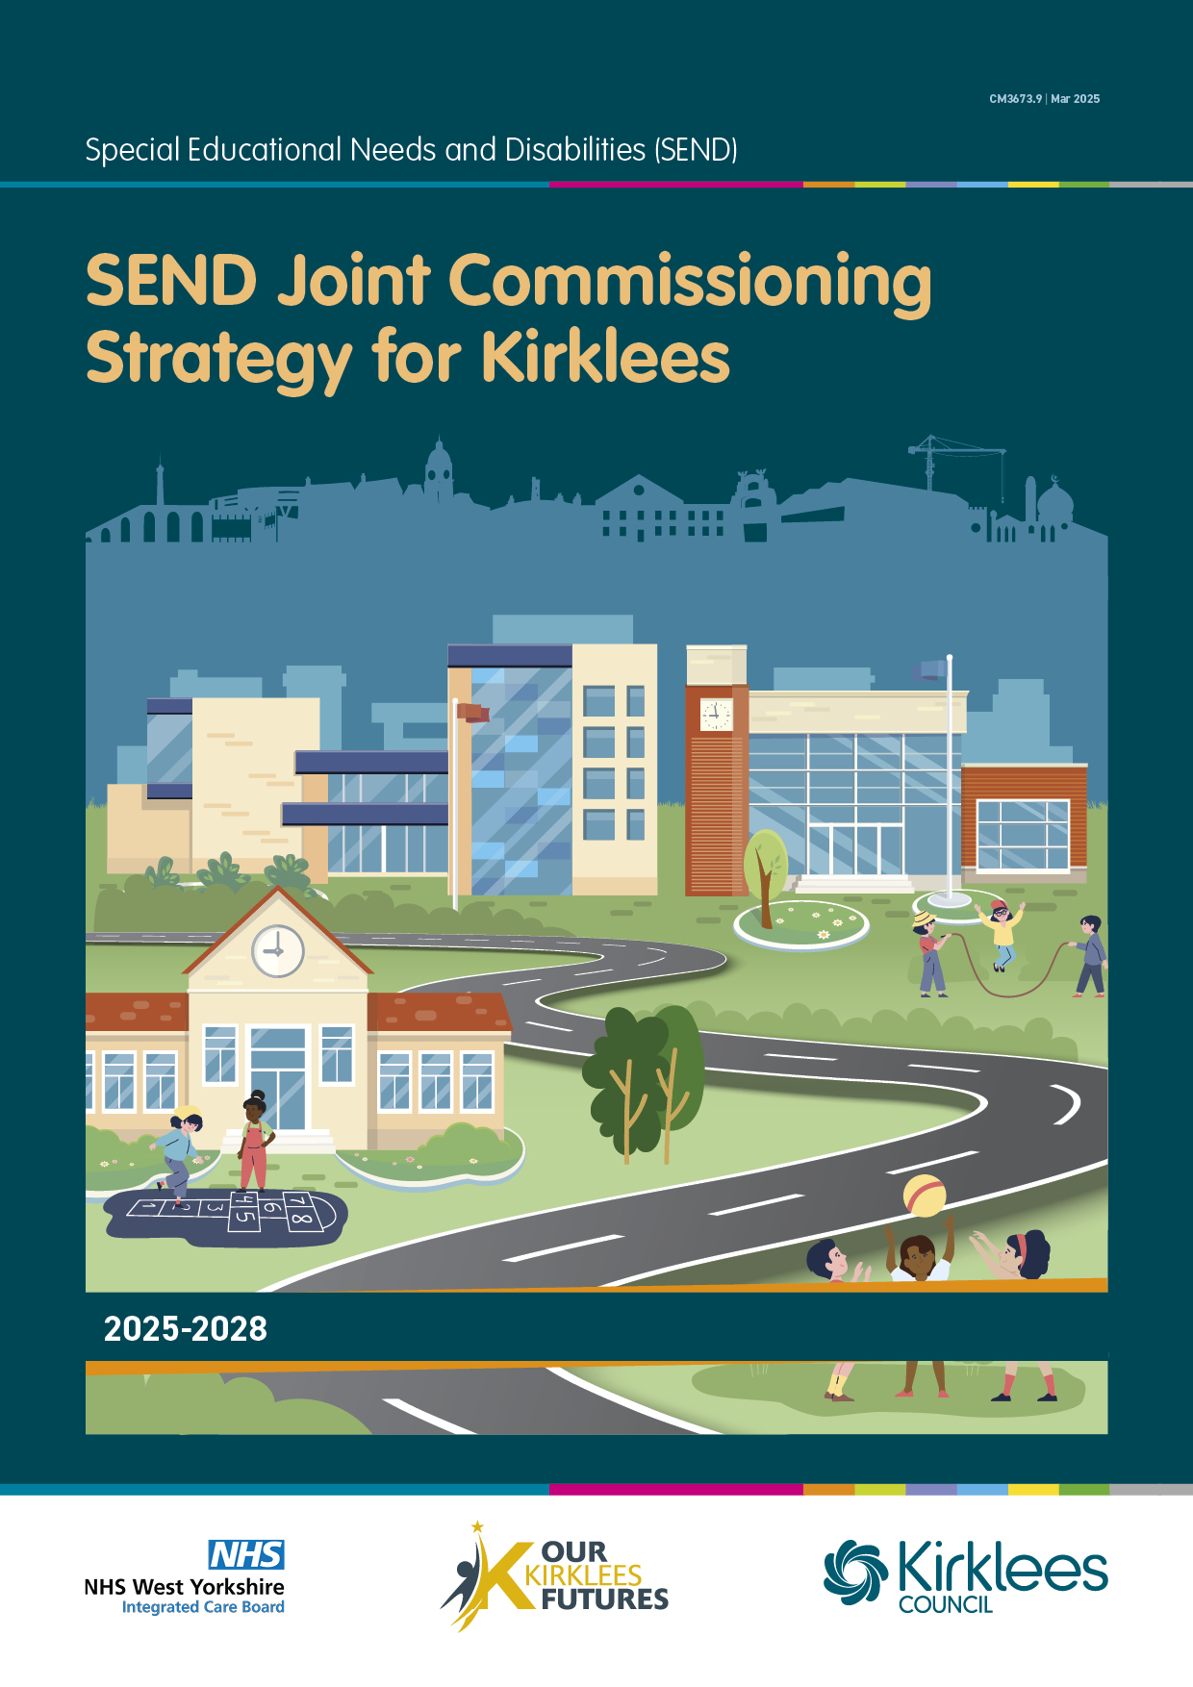

The Kirklees approach to Joint Commissioning to improve outcomes for children and young people with Special Educational Needs and Disabilities (SEND) 2025 - 2028

Contents

1. Our Joint Commissioning Strategy

2. Our vision

3. Our ambition

4. About our local area

5. Delivering our approach to joint commissioning

6. Population profile

7. Our approach to working together

8. Our challenges

9. Our commissioning and investment priorities

- Our Joint Commissioning Strategy
The aim of our strategy is to improve the lives and life chances of children and young people aged 0-25 with a special educational need and/or disability (SEND) in Kirklees. It is driven by the strategic intent to improve the education, employment, health and wellbeing outcomes of children, young people and their families.
This strategy sets out the collective commitment of all key partners across Kirklees to a joint commissioning approach that delivers effective, inclusive, integrated support. We will work with children and young people and their families to ensure we commission services that provide the outcomes they want and need. We are committed to supporting the development of the workforce across the partnership to ensure they understand our shared priorities, as well as develop the skills and knowledge to help our children to achieve their desired outcomes.
Kirklees received an Ofsted/CQC Area SEND inspection in February 2022 which highlighted many areas of good practice but also identified some areas for improvement. An action plan was developed, which complemented our existing SEND Transformation Plan to drive improved outcomes across the system.
The Kirklees Joint Strategic Needs Assessment (JSNA) is the primary source of data and intelligence which is used to inform the future shape of SEND provision across Kirklees. However, we also carry out engagement and co-production with families and communities about specific issues and make use of regional and national evidence and good practice.
Voice of Child and Co-production
We are determined to ensure that we understand what our children and families in Kirklees need from us in terms of support and information. We recognise that this can be different for different people and communities. To do this we are committed to meaningful engagement and co-production. This means that we seek out views and listen carefully to what people tell us. Co-production means that we will develop our services and support offer with our children, families and communities as equal partners.
The term "voice of the child" refers to the real involvement of children in expressing their views, opinions, and experiences. It includes both verbal and nonverbal communication and goes beyond simply seeking their views to actively including them in decision-making processes.
To ensure that the voice of the child is present in all our commissioned provisions we have a dedicated Voice and Influence team who are highly skilled in engagement and co-production with children and young people of all ages and abilities. The team are closely linked with the Integrated Commissioning team and have made valuable contributions to the development of recent services and reviews. Their findings are regularly presented and discussed at SEND Transformation & Commissioning groups and a host of other forums using a variety of creative methods, including video, sound and animations.
We have used this information to inform the priorities in this strategy. We will continue to regularly seek the views and experiences of children and families as we review the effectiveness of our SEND provisions.
What is Joint Commissioning?
Joint commissioning is a strategic approach to planning and delivering services in a holistic, joined-up way. This is important because there are many different partners involved in the education and support of children and young people with SEND, including the local authority, education settings, health and care provision, and voluntary sector organisations.
To effectively deliver positive outcomes for children and young people organisations must collaborate and share responsibility for planning, developing and procuring integrated services as well as monitoring their outcomes.
Our approach recognises that joint commissioning needs to happen at different levels:
- with individuals and their families and carers.
- with communities.
- and across larger populations.
This document details the steps that will be undertaken to achieve the vision of improving outcomes for children and young people.
This strategy builds upon well-established joint commissioning arrangements that have been in place in Kirklees for many years. We have an established integrated children’s commissioning team, which includes team members employed by the NHS Integrated Care Board (ICB) and the local authority, as well as a number of joint appointments, including the Head of Service.

The Commissioning Cycle
In Kirklees we use a commissioning cycle approach. The commissioning cycle describes the process of understanding the needs of a community and planning the provision of services to meet those needs. Once services are in place it is important to monitor and review those services to determine how well they are meeting needs. This helps to identify any gaps in provision or changes required and the intelligence and data informs the planning of future services.
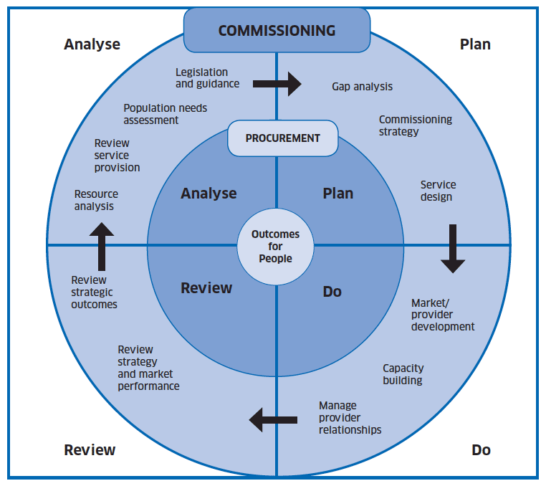
2. Our Vision
In Kirklees we are committed to child centred practice and our vision is:

‘For children and young people in Kirklees is that they have the best start in life. We want our young people to be proud to come from Kirklees and its localities. We want confident children ready to do well throughout their schooling and in life. We want to see our children making good progress and achieving the best outcome, with improved life chances for everyone. Our aspirations for children and young people with SEND are no different from what we would want for all children.’

Our council plan says that we want ‘children to have the best start in life’
This means:
- Confident children ready to do well at school and in life.
- Better outcomes for vulnerable children.
- Child focused activities that support families.
- As many children as possible staying with their families.

Our Inclusive approach
In Kirklees we strongly believe in an inclusive approach that will enable our whole community to thrive. Children and young people have told us that they would rather access schools and activities alongside their peers, instead of specialist provisions which can make them feel isolated. It is important to us that our young people with SEND feel valued and are a visible and play an active part of the community.
To support this we have developed the Inclusive Communities Framework This is a tool to enable us, as organisations and services in Kirklees, to work together and be better aligned, with a common approach. It will enable us to review and improve the way we work with communities.
We will work with our schools, partner organisations and commissioned services to share knowledge and skills to become more inclusive to all. We will ensure that all service descriptors and specifications require providers of to demonstrate how they make their services accessible and inclusive.
The West Yorkshire NHS Integrated Care Board (ICB) Children, Young People and Families Programme states:
Our vision for our Children, Young People and Families Programme is:
To close the gap in health and well-being outcomes for all children and young people across West Yorkshire, irrespective of where they were born, where they live and go to school.
All children and young people will have the best start in life and the support and healthcare needed to enable them to be safe from harm and to enjoy healthy lifestyles, to do well in learning and have skills for life.
The voice of the child and young person will be at the heart of everything we do.

Our SEND Big Plan says:
‘We’re ambitious for children, young people and parents and carers in Kirklees. We’re trying to make sure we support children and families at the earliest opportunity; our young people go to school in Kirklees with positive results; there’s a consistent and inclusive offer; and whatever our young people are interested in, we want them to excel.’

3. Our Ambition
Our aim is to ensure that children have the best start in life, with a focus on prevention and early support to better enable integrated delivery of services for children, young people and families.
Our aspirations for children and young people with SEND are not any different to all children, we want them to achieve the very best.
Our ambitions for children with special educational needs are described in a range of strategic documents. These include:

Our Kirklees Futures
Our Kirklees Futures is the overarching strategy for learning in Kirklees which is built around the principles of:
- Inclusion
- Resilience
- Equity
Our vision is that by 2030, Kirklees is a place where children and young people have the best start in life and are:
- Safe
- Healthy
- Happy
- Achieving
- Attending

SEND Big Plan
The SEND Big Plan describes our approach to transforming local area provision for children with SEND.
It was recognised that a specific focus on SEND provision was required and our SEND transformation journey began in 2020.
In 2023 we co-produced a refreshed SEND Transformation Plan. This involved working with our Parent Carer Forum, colleagues in Education, Health providers, Voluntary Sector partners, the ICB and the Council. We wanted to ensure that the voice of the child was clear in the plan and that everybody would be able to understand it when published. Our Young People’s Voice team worked closely with a wide range of children and young people to provide valuable insight.
People told us that they wanted a document which used plain language and avoided jargon to make it easier to understand. This resulted in SEND Big Plan which is published on our Local Offer website. The SEND Big Plan outlines the SEND Transformation Programme in Kirklees, with detailed programme plans sitting behind.
Within the development of our SEND Transformation Plan we have worked with all stakeholders across Kirklees to co-produce our ‘7
Inclusive Ambitions’, which are:
- We will have a renewed focus on responsive and holistic early intervention for children and young people, refocusing resources to produce a varied multi-agency offer including the use of the community and assistive technology and building the skills of the workforce to work preventatively.

- Families and carers feel empowered and supported. They have strong knowledge of the support available and there is a clear culture of trust between professionals and families. This will enable a shared understanding of need, the joint support required to meet them and a clear focus on aspirations.

- Children and young people feel included across the community and within education settings. Schools are celebrated and held accountable for their pupil-centred inclusive practice, and the contribution of individuals with additional needs is better understood across the system. This will mean that more children are able to be supported in settings across Kirklees.

- Children and young people are able to thrive within their education settings and are supported to access an education that is flexible and empathetic to their needs. Needs are addressed in a proactive and individual way. Schools focus on and measure an individual’s holistic outcomes, recognising success outside of purely academic achievements.

- The system works in an integrated way, using its resources to take a holistic and targeted approach to needs, whilst creating a seamless journey for children, young people and their families. This means that bureaucracy is reduced, and that children and young people are able to receive the right support at the right time.

- Professionals are empowered to meet the needs of children and young people and support them to achieve their aspirations. This is achieved through embedding a shared culture of proactivity; holistic skills and knowledge across the workforce; and creating clear pathways for meeting needs.

- Children and young people are supported to have clear aspirations for the future, with a focus on independence and preparing for adulthood. Throughout a young person’s journey, they are supported to achieve their aspirations through the support they receive. Ultimately, this will mean more young people enter education, employment and training as they progress into adulthood.

These ambitions will run through all our commissioning intentions.

4. About our Local Area

Kirklees is a vibrant place rich in history and is home to 433,000 people spread across 157 square miles, offering a blend of urban life and rural charm. Our landscape is dotted with small villages steeped in history, nestled in the rolling Yorkshire countryside, alongside large, proud towns with some of the best transport connections in the North. At the core of our borough are Huddersfield and Dewsbury, large centres with strong connections to major northern cities. Our smaller towns and villages include Batley, Birstall, Cleckheaton, Denby Dale, Heckmondwike, Holmfirth, Kirkburton, Marsden, Meltham, Mirfield, and Slaithwaite. All boast their own identities and stories as part of our proud industrial past.

In the 2021 census, Kirklees ranked 12th for total population out of 309 local authority areas in England and is the 5th most densely populated of Yorkshire and Humber’s 21 local authority areas.

The population of Kirklees at the last census was 433,300, demonstrating an increase of 1.1% in children aged under 15 years since the previous census. There are 100,100 children aged 0-19 across Kirklees. They are broadly more ethnically diverse than the adult population of Kirklees and nationally.

Kirklees has a diverse and multi-cultural population, as can be seen below.

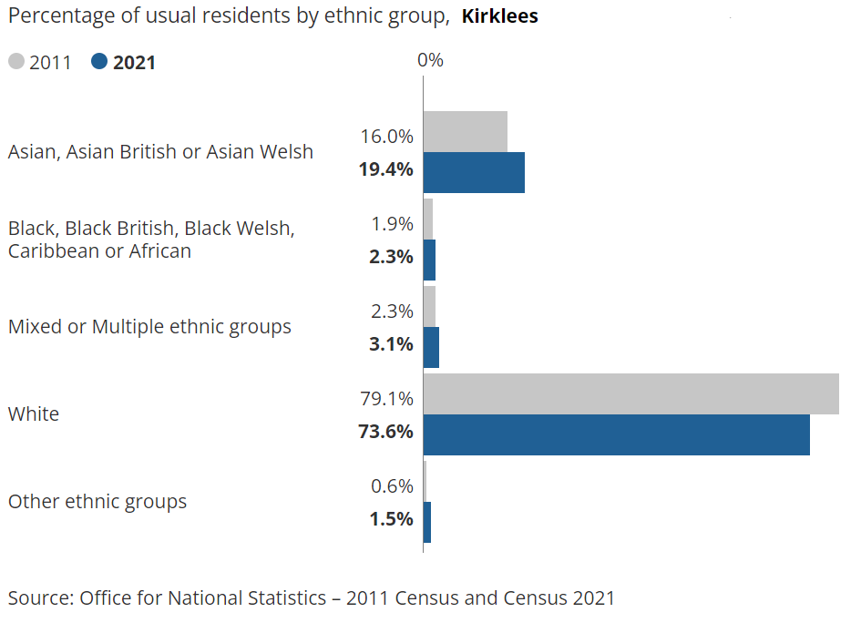

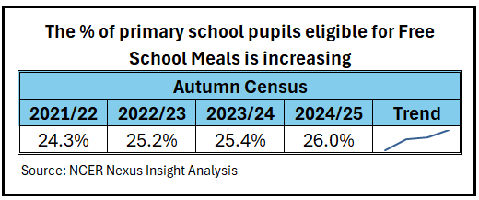

Kirklees Child Population
The Kirklees primary school population is more likely to experience higher levels of poverty and disadvantage than is the case nationally. This means that they are more likely to live shorter lives than their peers across the country.

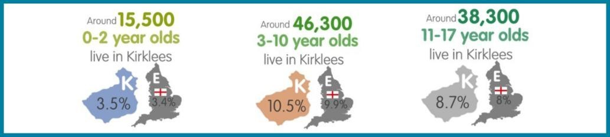

From the Autumn 2024 School Census there were 36,161 children in the primary phase of education and 27,136 in the secondary phase. They attend 144 Primary/First Schools, 2 Middle Schools, 24 Secondary Schools, 1 All -Through School and 6 state funded Special Schools.

The social profile of children in Kirklees is notably different from the profile of children nationally, for example, more children come from an ethnic minority background, live in poverty, and/or have English as a second language.

As of December 2024, the local authority maintains 4816 Education Health and Care Plans (EHCP) across all age groups. The proportion of children and young people of statutory school age who have an EHCP is lower than the national average but broadly in line with the Yorkshire and Humber regional average.

As with the national picture, our referrals for EHCPs have increased over the years. The EHCP cohort is over-represented within more deprived sections of our population. The data indicates the number of children / young people being educated in a mainstream setting with 9177 (representing 14.5%) as at Autumn School Census 2024, who have been identified as engaging in SEN support in statutory school provision.

4. Delivering Our Approach to Joint Commissioning

Our approach to joint commissioning starts with children, young people and their families and puts them at the heart of our approach. We are committed to using co-production approaches to understand the outcomes that children and families want and need.

We are also committed to using a data and intelligence led approach. The Kirklees Joint Strategic Assessment (JSNA) plays a key role in the identification of need and is the primary data source. This is a review of the current and future health and social care needs of a defined community, and includes a section focussed on people aged 0 to 25 living with Special Educational Needs and Disability.

In Kirklees our definition of joint commissioning is broad as we consider the ‘total resources’ available to meet those needs. This can involve the planning and purchase of services, but it also includes influencing, empowering and enabling the wider community. We recognise the important role community assets can play in supporting children and young people with SEND and their families. We want to work further with voluntary sector organisations, community groups, sports clubs, employers and residents.

The needs of children and young people with SEND and their families can be complex and may involve several services and providers. It is important, therefore, that we work in partnership to join up support across health, education, social care and the wider community from conception and birth to adulthood. This will help to ensure children and young people with SEND experience a seamless experience and positive outcomes across all phases on transition, particularly the transition to Adult Services.

So that we can effectively work together as a partnership and agree the priority areas for joint commissioning focus and activity we need to:

• Have one joint understanding, through our data and by constantly listening to the voice and experience of children and young people and their families and through listening to what front line staff say will improve the services.

• Carry out joint planning to identify gaps in services and priorities for investment.

• Jointly oversee delivery as services are procured and contract specifications put in place.

• Jointly review services with children, young people and their families to check that they have met the outcomes specified.

We have a SEND Transformation & Commissioning group which meets monthly to share information, data and good practice. The group has a wide-ranging membership from across the partnership and includes regular workshops, which are well attended.

Commissioning for Outcomes

We have embedded an outcome-based commissioning approach in Kirklees. Outcomes refer to the benefit or difference made to an individual as a result of an intervention and can be understood at three levels:
- Individual outcomes such as might be set out in an EHC plan
- Service level outcomes such as emotional wellbeing has improved in 10 schools
- Strategic outcomes: such as there has been a 10% increase in young people supported into employment
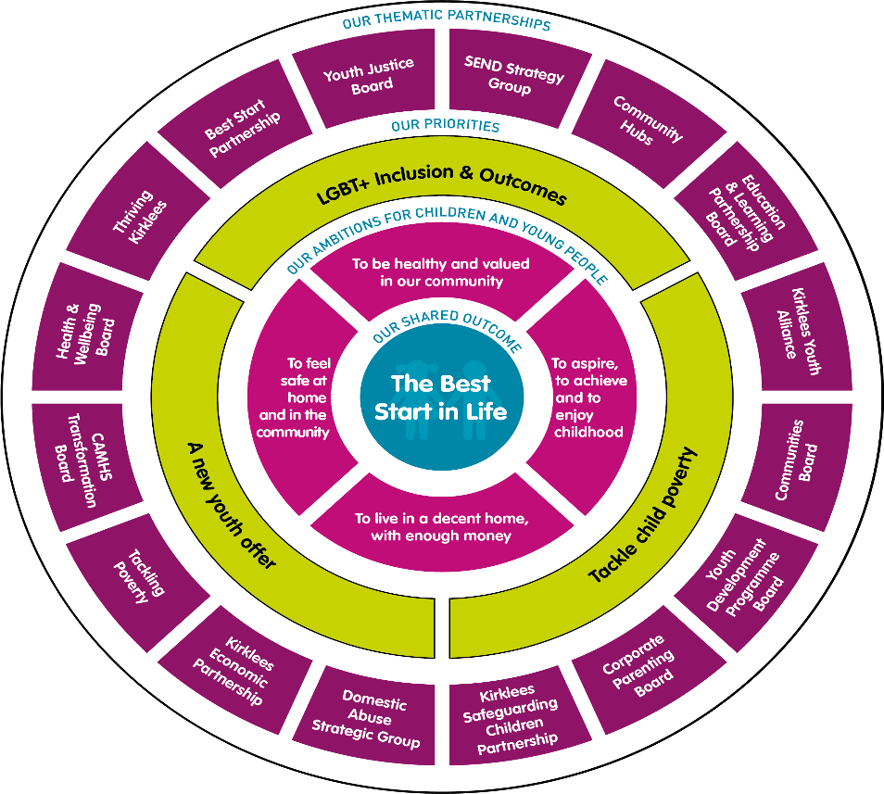
Outcomes based commissioning means moving from services being purchased or resources allocated from units of provision (hours, days or weeks of a given activity) for pre-defined needs to what is needed to ensure that the outcomes desired by service users are met.

Joint Funded Individual Packages
In some cases, the assessment of needs will mean that it is appropriate to jointly commission and fund packages of support for individual children between education, social care and/or ICB (NHS). For example, this may be a child attending an out of area residential school, due to significant health needs, or a young person ready for discharge from an in-patient setting. Decision-making processes and guidelines are in place to ensure transparency and fairness.
In accordance with delegated authority, most joint funded packages are discussed at Children’s Access to Services (CAS) Panel, with high cost and out of area packages and placements considered at the External Placement Panel.
In the event of a disagreement between parties in relation to joint funding, a dispute resolution process has been agreed. This includes escalation to director level, if required.

School Clusters
To facilitate closer working and neighbourhood commissioning, we have supported our schools to form ‘clusters’. Clusters are groups of mainstream schools that work together to share resources and expertise at a local level and capitalise on existing structures. This means more young people can get the support they need at the earliest opportunity. The intention is that schools will share their skills, expertise and good practice to develop local solutions and to pool their resources to locally commission support services, such as emotional wellbeing and mental health support or speech and language therapy (SALT) services.

Cluster working started in September 2024 in Kirklees and will keep developing. Close work with schools has been undertaken with the support of our local parent and carer forum (PCAN - Parents of Children with Additional Needs) to develop the cluster approach. The approach built upon existing strengths and 17 clusters were created. A geographical approach was taken to ensure that both the place-based support afforded by this organisation and the continuity for children provided as they move between schools at points of transition operated within the best interests of the children and families.

Key principles drive the approach:

Cluster working principles
- Commitment to meeting needs in the area and achieving best possible pupil outcomes
- Prioritising the greatest need vs advocating for own school
- Willingness to support and challenge (and be supported and challenged)
- Recognition of the impact of contextual factors not just levels of pupil need
- Active participation even when schools don't have immediate need for support
- Effective use of all available budgets (delegated and devolved)
- Commitment to reducing reliance on additional resources wherever possible (so that these can be reallocated)
- Recognition of the need to respond to contingencies as they arise (and ensure capacity available for this)
- Willingness to share good practice with/learn from other clusters
- Commitment to equity/positive outcomes across the area/county as a whole

In addition, an independent review and analysis of SEND provision in Kirklees has helped to identify opportunities for systemic change that could enable improve SEND provision for young people in Kirklees. The recommendations from the review were for Kirklees to explore a new mainstream SEND funding model that is based on the concepts of “predictable and exceptional need”. This is the level of need that is a predictable part of school cohorts and is best funded at school level rather than individually. The purpose of this is to enable a more consistent mainstream offer, with more capacity and flexibility to meet children's needs, resulting in less demand further up the system

Technology and Digital
In Kirklees we are committed to developing our use of technology and digital solutions to provide innovative solutions for our families and young people to achieve their desired outcomes and maximise their independence. We will maximise the opportunities from the refreshed WY ICB Data, Digital and Technology strategy. Our SEND Transformation Programme includes an Assistive Technology workstream with dedicated staff to research and develop ideas, as well as help our staff teams to understand and embed a technology enabled approach to assessment and provision.
5. Population profile
Children living with Special Educational Needs and/or Disabilities

Headlines - Kirklees Joint Strategic Assessment 2025

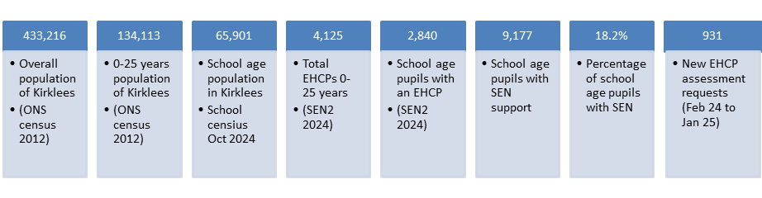

In Kirklees a regular survey of year 9 pupils is carried out as part of the Joint Strategic Needs Assessment. The data is analysed and broken down into cohorts. A summary of the health concerns of children with special educational needs can be found here. Kirklees Young People's SEN Health Survey

Headlines include
- 58% of children with SEN report good physical health, compared with 71% without SEN
- 41% of children with SEN report good mental health, compared with 50% without SEN

Most prevalent primary SEN in Kirklees

- Speech, language & communication needs 27%
- Autism Spectrum Condition (ASC) 21%
- Social, emotional & mental health needs (SEMH) 17%

Equality, Diversity and Inclusion
The Kirklees area partnership is committed to Equality and Diversity. We recognise that across Kirklees there is great diversity amongst the people who access our services. We must ensure that we comply with our statutory obligation under the Equality Act, 2010 to protect individuals from discrimination based on their protected characteristics.
To ensure that we, as a local area, comply with this duty, it will be expected that all jointly commissioned activities will have completed Integrated Impact Assessments (IIA). We will use the WY Integrated Care System (ICS) Equity and Fairness strategy to inform our work. Through undertaking analysis of the key issues on equality and diversity, we will better understand how children and young people are treated entering our services and keep service users at the centre of all the services that we deliver together.
6. Our Approach to Working Together
To maintain a healthy partnership approach to joint commissioning for SEND, a strong approach to governance is essential, with clear lines of accountability. The diagram below shows our approach in Kirklees:
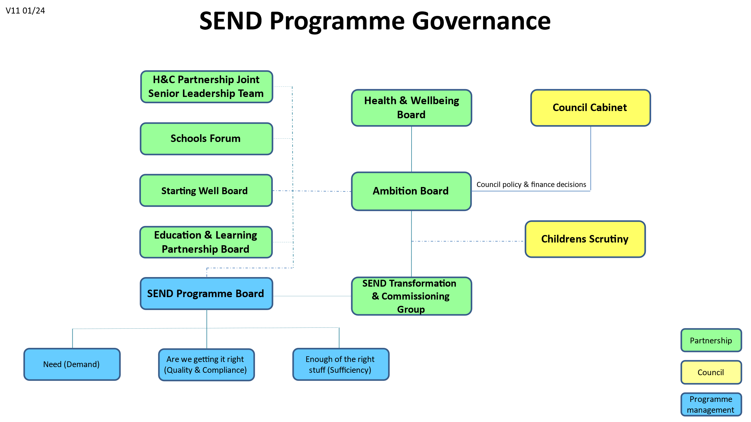

Starting Well
The Kirklees Health and Care Partnership has developed The Well Programmes which cover the whole ‘life course approach’ and are the place where we come together to work on focussed initiatives, join up services and plan together for the best outcomes for people. Within the overall programme Starting Well focuses on Families Together and the Whole Family Early Support Offer through Family Hubs and Start for life. Governance is through the Starting Well Board and a work plan is currently being developed to support the priorities.
The Starting Well Board is accountable to the ICB Place committee.
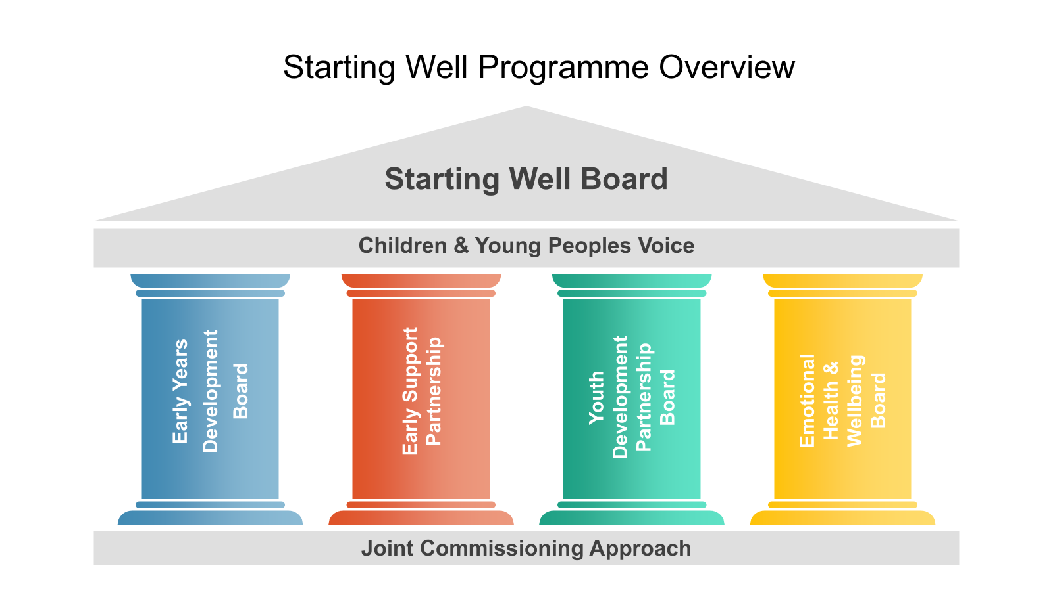

NHS Integrated Care Board
Recent NHS reforms have led to the creation of Integrated Commissioning Boards (ICBs) which join up the previous smaller Clinical Commissioning Groups (CCGs) into larger regions. One of the intentions of this is to encourage greater consistency of provision across regions and economies of scale by commissioning on a larger footprint where appropriate.
The West Yorkshire ICB has recently used an NHS England quality assurance framework to review the SEND governance and commissioning arrangements across the partnership. Work is taking place to establish strengthened governance arrangements that support strategic oversight and assurance in relation to SEND statutory duties as we drive further accountability across West Yorkshire.
This will enable collective decision making as we make the best use of resources and consider opportunities for joint commissioning, maximise collaborative working and unblock any barriers to service delivery. Additionally, oversight of the strategic commissioning approach will continue to be informed through national guidance and supported through West Yorkshire SEND datasets that ensure availability of effective health provision.

7. Our Challenges
Kirklees is not unusual in facing some challenges and pressures relating to SEND provision. In common with the national picture, we have seen rising demand for SEND support and special school places. These trends are described in more detail in the Kirklees Joint Strategic Assessment (KJSA) and the SEND Sufficiency Strategy for Kirklees 2025-2028.
As a partnership we have already undertaken extensive work to address these challenges and have achieved significant successes over the past five years but there are still areas we recognise we need to improve, including:
- Inclusivity - we need to be more explicit about our inclusive approach across all our provisions and services. We need to understand more about our communities and demographics and their access to support.
- Sufficiency - we lack enough capacity in all settings and placements across our SEND system in particular early intervention and support. Have we got enough of the right things?
- Holistic support - people have told us that support can be fragmented e.g. support for neurodiverse young people.
- Exclusions - too many of our young people with SEND needs are excluded from their settings, particularly those with SEMH with SEND Support.
- Progress - the educational achievement of children across Kirklees is below that of children nationally and children and young people with SEND are disadvantaged further.
- Preparing for adulthood - people have told us that the transition journey is not always clear and the difference between children and adult provision is too great. We need a greater focus on maximising independence.
- Measuring the impact of our services - we need to be confident that the services we commission make a positive difference to people.
- Some of our systems and services are under pressure e.g. Speech and Language therapy (SALT).
- Early intervention and assessment - we need to identify any issues with children and families as early as possible so that we can put timely interventions in place and avoid the need for more intensive support later.

8. Our Commissioning and Investment Priorities
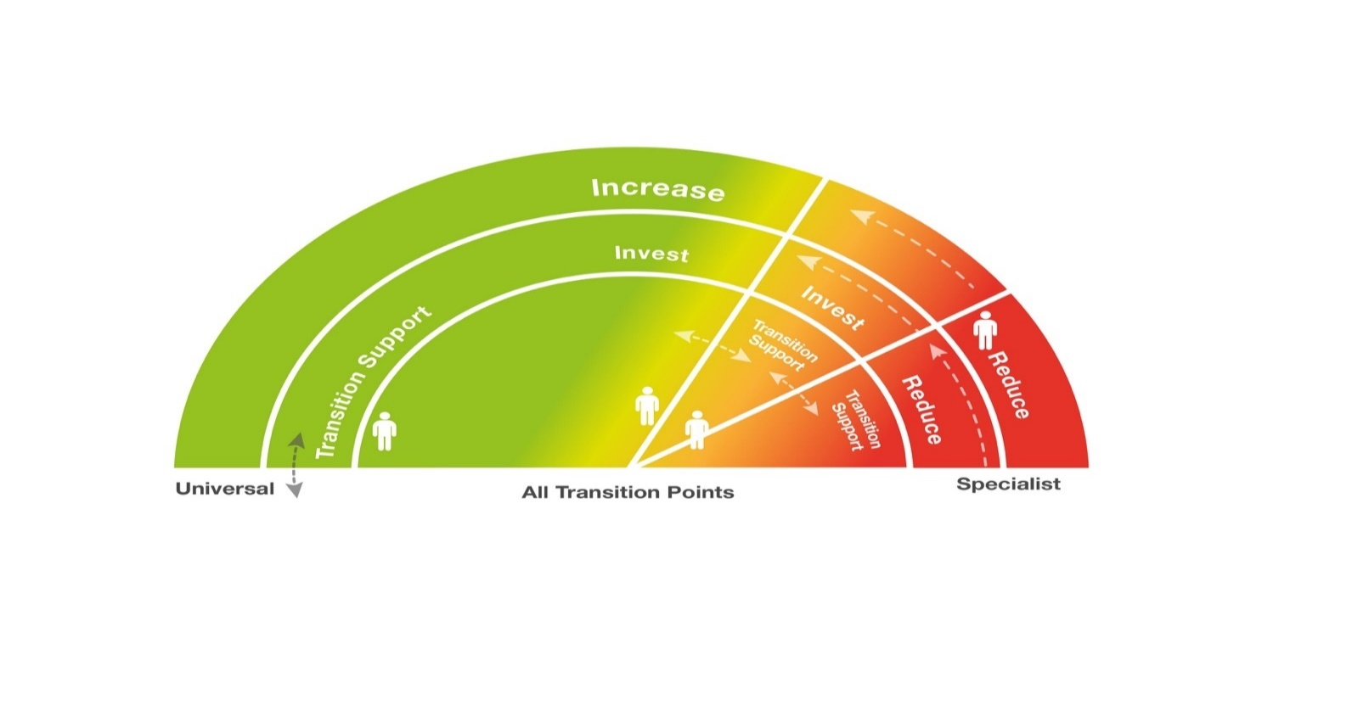
This section outlines our identified commissioning and investment priorities for 2025-2028. It is important to recognise that elements of support not listed here will continue. Evidence of other interdependent actions are within our SEND Transformation Plan and associated workstreams.

Improve outcomes- Increase Inclusion Reduce specialist costs £
Increase investment in universal and early help

Key to our investment priorities is the shifting of investment from specialist provision to early intervention. The above model illustrates how we will demonstrate outcomes achieved from often complex co-dependent workstreams. For example, to reduce the demand for specialist SALT interventions, we need to invest more in early intervention in early years settings.

Commissioning and Investment Priorities for 2025 - 2028
This section outlines our commissioning and investment priorities for 2025 - 2028. These are the key areas where we will be assessing services, directing investment and taking action.

- Developing our inclusive approach

- Sufficiency of suitable education placements for children with SEND

- Preparing for adulthood

- Improved support for speech, language and communication needs

- Provision for children & young people with Social, Emotional and Mental Health (SEMH) needs

5.Timely access to assessment and services

6.Effective early intervention for children and families

7. Develop our short breaks offer

Glossary
- ASC - Having an Autistic Spectrum Condition (ASC) means that the person has a different way of understanding other people and the world around them. ASC is a lifelong developmental disorder, not an illness or a disease so there is no ‘cure’ but there are many ways that difficulties can be managed. Here are some of the things you might see, in various combinations and from mild to severe, in people who have ASC:

- CAMHS - CAMHS stands for Child and Adolescent Mental Health Services. CAMHS is the name for the NHS services that assess and treat young people with emotional, behavioural or mental health difficulties. CAMHS support covers depression, problems with food and eating, self-harm, abuse, violence or anger, bipolar disorder, schizophrenia and anxiety, among other difficulties.

- EHCP - An Education, Health and Care Plan (EHCP) outlines any special educational needs that your child has. It also covers the support your local authority must put in place to help your child: The EHCP is a legal document. That means your local authority has a legal obligation to provide the support in the plan.

- ICB - Integrated Care Board

- NHS - The NHS stands for the National Health Service. It refers to the Government-funded medical and health care services that everyone living in the UK can use without being asked to pay the full cost of the service. These services include; visiting a doctor or a nurse at a doctor’s surgery.

- OT - Occupational therapy (OT) teaches you how to adapt. It can help you perform any kind of task at school, work, or in your home. You'll learn how to use tools (you may hear them called assistive devices) if you need them.

- SALT - Speech and language therapy (SALT) provides treatment, support and care for children and adults who have difficulties with communication, or with eating, drinking and swallowing. Speech and language therapists (SLTs) are allied health professionals. They work with parents, carers and other professionals, such as teachers, nurses, occupational therapists and doctors.

- SEND - Special educational needs and disability. A child or young person has special educational needs and disabilities if they have a learning difficulty and/or a disability that means they need special health and education support, we shorten this to SEND.

- SEN Support - Children with special education needs (SEN) who don't have an Education, Health and Care Plan (EHCP) should have provision made for them in school through ‘SEN Support'. SEN Support should focus on a cycle which requires the school to assess, plan, do and review, to ensure they understand the child’s needs and the support needed to help them make good progress. This is therefore likely to differ according to the individual needs of each child.

