Department for Education - SEND Reform: ‘Putting Children and Young People First’
Consultation Summary

Executive Summary

The government has published a major consultation proposing the most significant reform of the special educational needs and disabilities (SEND) system in a generation.

The core shift is away from a binary 'Education Health and Care Plan (EHCP) or nothing' model towards a single inclusive system with graduated levels of support — placing mainstream education at the centre.

A significant amount of funding (over £7 billion nationally) has been committed in advance of legislative change, with the aim of building the conditions for reform before new statutory duties take effect.

Major changes to EHCPs and the statutory framework are expected later this decade, with full changeover by September 2030.

For local authorities, this means significant new responsibilities in commissioning, partnership working and capital investment, alongside reform of how SEND funding flows through the system.

- The EHCP remains in place for all existing holders until at least September 2030 — no immediate change for current plan holders.
- A new Individual Support Plan (ISP) will replace 'SEN support' for most children, without requiring statutory assessment.
- Local authorities will have new duties to commission Experts at Hand (specialist professionals in mainstream settings) and Inclusion Bases.
- SEND funding will be rebalanced away from reactive, plan-led spending towards earlier, mainstream-based investment.
- Local SEND partnerships across education, health and the council will be strengthened with clearer accountability.
- The consultation is open for responses until 18 May.

Key Dates and Timeline

2026–27 onwards | £1.6bn Inclusive Mainstream Fund begins.  National Inclusion Standards published.  Experts at Hand roll-out starts.  Capital investment in Inclusion Bases.  (the amount per Local Area is yet to be agreed)
By September 2029 | Transition-point reviews begin.  At key transitions (end of primary, secondary and post-16), children are assessed for either a new Specialist EHCP or an Individual Support Plan (ISP).
September 2030 | All existing EHCPs and protections remain in place until this date. Full statutory changeover to the new system.

Background: What Problem Is Being Addressed?

The case for change concludes that the current SEND system is fundamentally misaligned with children's needs and increasingly financially unsustainable. The government identifies the following core failures:
- Too many children experience delay and exclusion before support is provided.
- Families must navigate lengthy, adversarial processes to access even basic help.
- The EHCP has become the main gateway to all support, rather than a targeted tool for the most complex needs — creating a 'fight for a plan' culture.
- Despite substantially increased high-needs funding, outcomes have not improved and gaps persist.
- Provision varies enormously between areas, creating an inconsistent offer to all.
- Local authorities face unsustainable financial pressure, while schools struggle to access specialist expertise in a timely way.

Reform Principles

The government has built the consultation around five principles for the reformed system:

Principle | What it means
Early | Support is identified and put in place as soon as needs emerge, preventing escalation.
Local | Children learn close to home alongside their peers; specialist provision used only where genuinely needed.
Fair | All settings are resourced to meet common needs without families having to fight, with clear safeguards for specialist provision.
Effective | Support is grounded in evidence, with clear routes to apply what works and improve long-term outcomes.
Shared | Education, health, care and community partners work together with families and children at the centre.

The System Model: A Continuum of Support

The consultation proposes replacing the current system with a single continuum of support. Rather than fixed thresholds, children move fluidly between levels as their needs change — including stepping back down to less intensive support. The key features of this model are:

- All children start in the Universal Offer.
- Additional support is layered on top — not substituted for what is already in place.
- Movement between levels is expected and normal.
- Statutory plans (EHCPs) become one part of the system, not the organising centre.
- Specialist expertise is brought into mainstream settings, rather than children being moved out by default.

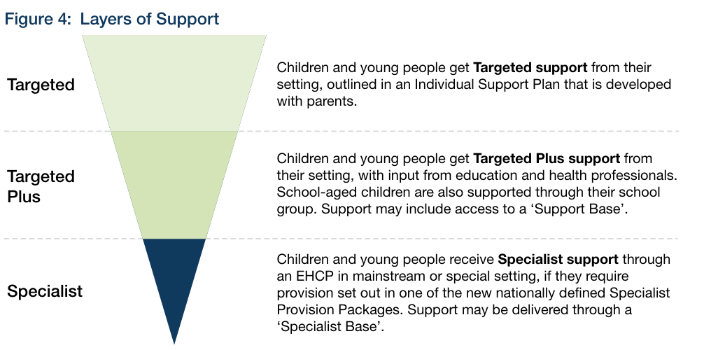

Level 1: Universal Offer

What is being proposed?

A strengthened Universal Offer forming the foundation of the SEND system across early years, schools and colleges. This includes high-quality teaching, inclusive environments, early identification of barriers to learning, and strong partnerships with families and local services. To support this, the government is proposing:

- £1.6bn Inclusive Mainstream Fund over three years from 2026–27 to help settings become more inclusive.
- National Inclusion Standards defining what good inclusive practice looks like, based on evidence.
- A new statutory duty on schools to publish an Inclusion Strategy, replacing the current SEN information report.
- Inclusion embedded within Ofsted and CQC Area inspection frameworks.
- Significant investment in workforce training and capability.
- Inclusive design guidance for local authorities and settings to use their estate (buildings) to support inclusion.

What is being consulted on?

- The content of the Universal Offer and National Inclusion Standards.
- How schools should be held accountable for inclusive practice.
- What national SEND training should cover.

Level 2: Targeted Support

What is being proposed?

Targeted support provides additional, school-led help on top of the Universal Offer for children whose needs persist, without requiring statutory assessment. Support is recorded in a new Individual Support Plan (ISP), which will be:

- Digital and portable across settings and phases.
- Co-produced with families.
- Reviewed regularly.

Examples of support at this level include small-group interventions, curriculum adaptations, additional adult support, structured pastoral or behavioural approaches, and reasonable adjustments.

What is being consulted on?

- How Targeted support should operate in practice.
- What good-quality ISPs should contain.
- How schools should evidence effectiveness and quality.

Level 3: Targeted Plus Support

What is being proposed?

Targeted Plus support provides more intensive help for children whose needs require specialist input but not full specialist placement. Children remain in mainstream education with an ongoing ISP, while accessing two new system-wide enablers:

Experts at Hand - A new programme bringing education and health professionals directly into mainstream settings to advise staff, work directly with children, build workforce capability and reduce reliance on assessments and reports. This is a system-wide enabler available across all mainstream settings, funded with £1.8bn nationally.

Inclusion Bases - Physical and organisational provision within mainstream settings, enabling specialist help without removing children from mainstream education. There are two types:
- Support Bases — linked to Targeted support (organised by schools and trusts).
- Specialist Bases — commissioned by the LA linked to Specialist Provision Packages (see Level 4 below).

What is being consulted on?

- How Experts at Hand should operate locally — with LAs having a key commissioning role.
- How Inclusion Bases should be commissioned and quality-assured.
- How Targeted Plus support should be governed and evaluated.

Level 4: Specialist Support and EHCP Reform

What is being proposed?

A reformed specialist system built around Specialist Provision Packages — defined, evidence-based packages of support for children with the most complex needs. Key changes include:

- EHCPs will guarantee access to a Specialist Provision Package and focus on outcomes rather than inputs.
- Over time, only children requiring a Specialist Provision Package will need an EHCP — with most children supported via ISPs instead.
- Specialist support may be delivered in specialist settings or in mainstream settings via Specialist Inclusion Bases.
- ISPs will provide continuity across transitions and settings at all levels.

What is being consulted on?

- The design and scope of Specialist Provision Packages.
- How EHCPs should change in content and focus.
- Parental preference and placement decisions.
- Transition arrangements to the new system.

Funding and Resource Reform

The headline investment

The government is committing over £7bn of additional SEND investment (revenue and Capital), frontloaded ahead of legislative change. This is intended to build the conditions for the reformed system before new statutory duties come into force. We do not yet know the value of Kirklees allocations for each of these areas.

Amount | Fund | Purpose
£1.6bn | Inclusive Mainstream Fund (over 3 years from 2026–27) | Strengthen Universal Offer and early Targeted support
£1.8bn | Experts at Hand | Embed education and health professionals in mainstream settings
£3.7bn | Capital investment | Expand Inclusion Bases and specialist capacity
£200m+ | National SEND workforce training | Build professional capability across the system

How funding will flow differently

The consultation proposes a fundamental rebalancing of SEND funding away from reactive, plan-led spending and towards earlier, mainstream-based, cohort-level investment:

- More funding in mainstream core budgets to plan for predictable need.
- Funded without EHCPs, removing the financial incentive to escalate to statutory plans.
- Experts at Hand funding enables specialist input without statutory assessment.
- High Needs funding increasingly reserved for Specialist Provision Packages, improving predictability and value for money.
- Over time, schools are expected to pool a proportion of SEND funding within local groups to share risk and capacity, following a model like the Kirklees Cluster approach.

What is being consulted on?

- How SEND funding should be rebalanced nationally and locally.
- How pooled funding should operate.
- How Inclusive Mainstream Fund spending should be quality-assured.
- How funding reform should apply across early years, schools and post-16.

Accountability, Partnership and System Leadership

What is being proposed?

- Stronger statutory duties on settings to deliver inclusive practice.
- Inclusion embedded in Ofsted and CQC inspection frameworks.
- Strengthened local SEND partnerships across education, health and local government.
- Improved complaints, mediation and resolution processes to reduce adversarial escalation.
- Oversight of reform delivery by the Children's Commissioner.

What is being consulted on?

- How accountability should operate at setting, trust and local area partnership level.
- How local SEND partnerships should function and be resourced.
- How disputes should be resolved more quickly and fairly.

Implications for the Kirklees Local Area Partnership

The full implications will depend on the outcome of the consultation and subsequent legislation, the proposals have significant implications, these include:

- Commissioning: LAs will have a central role in commissioning Experts at Hand and capital investment in Inclusion Bases — this will require early planning and partnership with schools and NHS partners, and be informed by evidence.

- Finance: The rebalancing of High Needs funding away from reactive EHCP spending will affect local budget modelling. The pooled funding model will require schools to engage in new resource-sharing arrangements, but our Cluster Communities mean that we have made a good start to work in this way.

- EHCPs: No immediate change for existing plan holders, but we will need to begin to consider how transition arrangements will be managed from 2029 onwards.

- SEND partnerships: Strengthened partnership duties will require closer working between the council, schools, health services and the voluntary sector in partnership with our families.

- Workforce: The emphasis on inclusive practice and the Experts at Hand programme will have workforce development implications.

